Electrocardiography
Review

Nova Southeastern University
College of Osteopathic Medicine
Cardiovascular Physiology 2002

Ben Lawner

This packet is in no way whatsoever even remotely officially associated with Dr. Mayrovitz’s course material. Use at your own risk!

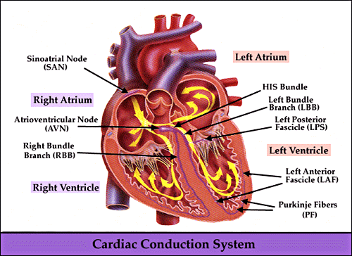

I. Relationship between EKG and cardiac AP conduction events

The wave of depolarization as seen by an EKG machine is obviously related to the cardiac cycle. The “P” wave is the first (normally) positive deflection on the EKG. P waves correspond to atrial depolarization / contraction. The wave of depolarization then progresses to the atrioventricular node. The time it takes for the depolarization wave to reach the AV node is labeled as the “PR” interval. In healthy individuals, it takes approximately 0.12-0.20s for the impulse to reach the AV node. Propagation through his bundles, purkinje fibers, and the bundle brances normally occurs without EKG deflection. The next deflection on the EKG is often called a “Q” wave. The Q wave signifies the beginning of ventricular depolarization. The QRS complex, a normally positive deflection, represents ventricular depolarization. Because the left ventricle has more mass and thus conducts more current, the QRS complex approximates left ventricular activity. The QRS complex contains vital information about the status of your patient’s conductive system. Widened QRS complexes (> 0.12s or three small horizontal boxes) indicate poor conduction. Patients with bundle branch blocks, fibrosis, and other pathological conditions may display QRS widening. The direction of QRS deflection has a major role in determination of axis and the mean QRS vector. Prior to interpreting any cardiac dysrhythmia, it is important to understand the correlation between PQRST and electrical activity within the heart.

EKG segment/wave | Correlation | Normal parameters
P wave | Atrial depolarization | Upright in I, II, III and uniphasic
PR interval (P wave to R wave) | Impuse going from atria to AV node | 0.12-0.20 seconds in duration
Q wave | Beginning of ventricular contraction, first downward deflection of EKG | Less than 1/3 height of R wave, narrow
R wave | Next positive deflection, ventricular depolarization
QRS complex | Ventricular depolarization | Normally less than 0.12s, narrow. Notching may signify a bundle branch block
ST segment | Measured from the RETURN to baseline after QRS to the beginning of the T wave. ST segment still represents ventricular depolarization | Normally isoelectric (FLAT).
T wave | Ventricular repolarization | Upright in all leads except AVR. Rounded.

Diagrammatic illustration:
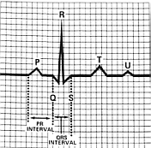
Figure 1: Parts of the EKG. Note the upright P wave and narrow QRS.

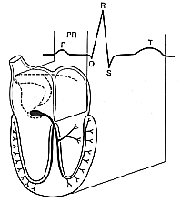
Figure 2: Parts of the EKG related to electrical activity within the heart.

II. Standardized EKG measurements

NOTE: The figure below should read, “0.04 seconds” instead of “0.4 sec”
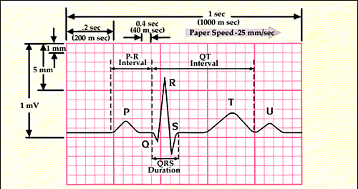

The above illustration indicates how voltage is measured. Along the horizontal axis is a graph of time. Each small box is 0.04seconds long. Consequently, one large square is 0.2 seconds in duration. Conveniently, the length of the PR interval on a normal EKG should NOT exceed 0.2 seconds. The vertical axis is a measurement of “voltage.” When determining axis and hypertrophy, the vertical axis provides useful information about signal amplitude. Two large boxes are 1 mV. Most EKG machines are standardized to the 1 mV calibration. Also notice that one small box in the VERTICAL column is equal to about 1mm. Suppose someone presents to the cardiologist with an R wave that spans the length of 7 large boxes. If 1 small box=1 mm and one large box=5 mm, then his R wave measurement is estimated at approximately 35 mm. R wave amplitude greater than 35 mm is an indicator of hypertrophy, or enlargement. These EKG parameters are “must know” because many dysrhythmias depend upon rate of contraction and/or conduction time. If you recall that a first degree AV block is always present when the PR interval exceeds 0.2 seconds (1 large horizontal box), then the diagnosis is easy. To review, time is plotted on the horizontal axis and amplitude is given on the vertical axis.

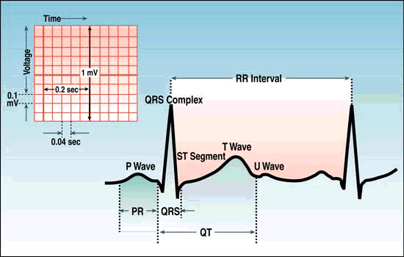

III. Lead Placement and Polarity
Placement and polarity are intrinsically related. No matter what mnemonic you choose, it is important to remember both anatomical landmarks and electrical direction. If the two are confused, determination of axis is impossible. Conveniently, most EKG machines are paramedic and firefighter proof. Most electrodes are labeled according to the associated body part.

BIPOLAR LEADS
Labeled bipolar because one lead is used as a negative pole and another as the positive, these leads form the dreaded, “Einthoven’s triange.” Electrical axis can often be approximated by glancing at these three leads that lie in the body’s frontal plane.

LEAD I:
Lead one goes from the RIGHT ARM (RA) to the LEFT ARM (LA). LA functions as the positive electrode. Many students remember the placement of lead one according to the mnemonic, “smoke over fire.” In clinical situations, the LA electrode is black (smoke) and is placed over the (LL) electrode, which is red.

LEAD II:
This lead most closely approximates the normal cardiac axis. It extends from the RA to the LEFT LEG (LL.) LL is the positive (RED) electrode. Along lead II, the normal EKG should read a positive deflection because this lead lies directly along the wave of depolarization. Mean QRS vectors should end up somewhere along the Lead II axis. (Point to the patient’s lower left quadrant).

LEAD III:
This lead extends from the LA to the LL. EKG deflection in this lead varies, but it is usually positive. LL is the positive electrode.

AUGMENTED LIMB LEADS
These leads called, “augmented” because the EKG machine must amplify their signal to produce a visible tracing. These leads use other leads as a reference point, and are also useful for electrical axis determination. There are no actual electrodes for these leads. Rather, the EKG machine estimates leads AVF, AVL, and AVR by integrating signals from other electrodes. These leads actually form three other intersecting lines of reference within Einthoven’s triangle.
LEAD AVR:
Augmented limb lead right uses the right arm as the positive electrode. The remaining two electrodes are negative.

LEAD AVL:
Augmented limb lead left uses the left arm as the positive electrode.

LEAD AVF:
Augmented limb lead “foot” uses the left foot as a positive electrode.

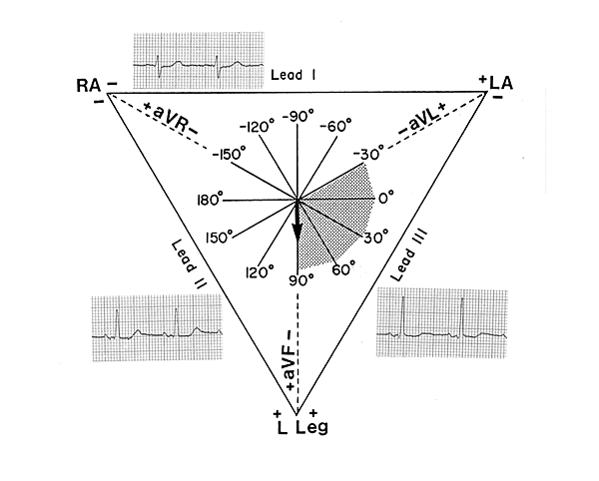
PRECORDIAL LEADS:
When taking a “12 lead EKG,” it is important to look at electrical activity within the transverse plane. Precordial leads are “chest” leads placed across the patient’s anterior chest wall. Precordial leads provide information about how the heart is rotated within the transverse plane. Precordial leads are V1-V6. V-1 looks directly at the heart’s right side, or anterior surface. Leads V3 and V4 look at the interventricular septum. Leads V5 and V6 look at the left side of the heart. Theoretically, leads V4,V5, and V6 should produce a positive deflection on the EKG machine because they will lie along the mean QRS vector or wave of depolarization. Physicians use the size of the R wave in relation to the chest lead to determine pathology. Topographical anatomy is the key to understanding precordial leads. The chest leads simply follow the pattern of the heart within the thorax:

LEAD | PLACEMENT | REGION OF HEART EXAMINED
V1 | R parasternal border of 4th ICS | Anterior wall
V2 | L parasternal border of 4th ICS | Anterior wall
V3 | Between V2 and V4 | Septal wall
V4 | 5th intercostals space, mid clavicular | Septal wall
V5 | Between V4 and V6 | Anterio-lateral wall
V6 | 5th intercostals space, mid axillary line | Lateral wall

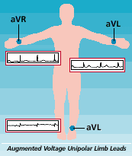

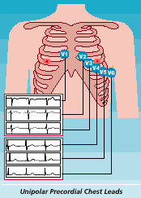
IV. Axis determination

Electrical axis measurements are obtained from the evil mean QRS vector. By looking at positive and negative deflections within the frontal plane, the practitioner can reliably approximate where the mean QRS vector actually is. Imagine an axis system superimposed upon Einthoven’s triangle:

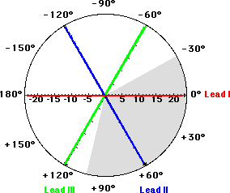

Lead one lies in a straight line between 0 and 180 degrees. If the EKG machine produces a positive deflection in lead one, then the mean QRS vector points SOMEWHERE to the patient’s left. Positive deflections must necessarily follow the lead’s polarity. The mean QRS vector of the “NORMAL” patient lies somewhere between 0 degrees at positive 90. A positive lead one deflection only tells the practitioner that the patient’s mean QRS vector is pointing somewhere between –90 and +90 degrees. If the lead one deflection is negative, then the patient in question most always has a “right axis deviation.” That is to say, the direction of depolarization is OPPOSITE the polarization of lead one.

Rather than dropping perpendiculars, I will provide you with several quick and easy methods for estimating electrical axis and mean QRS vector. Once you understand the association between vectors and depolarization, estimation of axis is easy.

METHOD ONE: Use leads I and AVF
Imagine a sphere of charge around your patient’s body. The sphere is divided into positive and negative halves, according to the polarity of the limb lead in question. Since lead one lies along the 0 to 180 degee line and uses the LA as a positive electrode, any positive deflection in lead one indicates a LEFT pointing mean QRS vector. Recall that lead AVF is the augmented limb lead/left foot. The positive half of the AVF sphere would correspond to the patient’s lower half. Thus, a positive lead one deflection and a positive lead AVF deflection places the mean QRS vector somewhere within the physiologically normal range.

1) Determine whether the deflection in lead I is positive or negative
If the QRS in lead one is positive, then the QRS vector points to the patient’s left. RAD is indicated when the lead I QRS is negative

2) Examine lead AVF
If the QRS in lead AVF is positive, then the QRS vector points somewhere in the 0-90 degree (normal) quadrant. This concept is often termed the double thumbs up sign.

SCENARIO ONE:
Positive Lead I
Negative Lead AVF
The QRS vector points to the patient’s left, but the negative deflection in the AVF leads indicates that depolarization is proceeding in a direction that opposes the positive polarity of the left foot. Thus, the mean QRS vector MUST be in the 0- negative 90 degree quadrant. This intersection of the two regions signifies left axis deviation.

SCENARIO ONE
Negative Lead I
Negative Lead AVF
The QRS in lead one is negative, indicating a RIGHT axis deviation and a mean QRS vector that points to the patient’s right. Thus, the mean QRS vector lies SOMEWHERE between 90 degrees and negative 90 degrees. To localize the axis quadrant, examine AVF. AVF is negative, indicating that the wave of depolarization is OPPOSITE to the expected positive polarity of AVF. The QRS vector thus is pointing to “no man’s land,” and signifies EXTREME right axis deviation. (Mean QRS vector lies between 180 and negative 90 degrees.

METHOD TWO: Use leads I, II, and III (Einthoven’s triangle.)
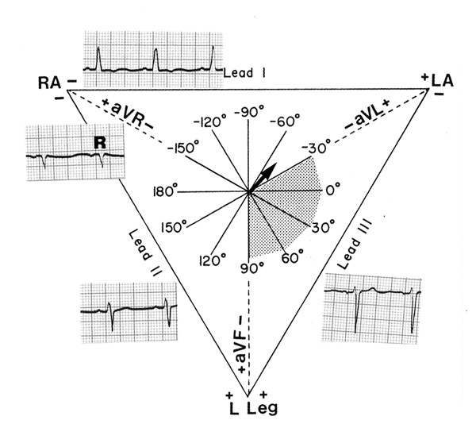

Lead one is mostly positive. You know that the mean QRS points somewhere to the patient’s left side. Lead II is mostly negative. The mainly negative deflection indicates that the wave of depolarization (in lead II) propagates AWAY from the left leg lead. To confirm this diagnosis, look at lead III. Lead III reveals an extremely negative deflection. The only possible conclusion is that the mean QRS vector points to the upper left quadrant (between 0 and –90 degrees). This is called pathological left axis deviation. LAD from 0 to negative 30 degrees does not always indicate disease. If lead two was isoelectric (half above and half below) in the above example, then the mean QRS vector is more likely closer to the physiological LAD range. If you get an isoelectric complex in a particular lead, then the mean QRS vector proceeds perpendicularly away from the lead’s normal axis. To summarize this example, a positive lead I and a negative lead III indicates some type of left axis deviation. Because the lead II QRS is mostly negative, the QRS vector is not within the physiological range of 0 to negative 30 degrees.

METHOD THREE:
If all else fails, the memorization method always works. If the visual examples fail to make sense, consider the “quick and easy” axis determination chart:

AXIS | LEAD ONE | LEAD II | LEAD III
Normal axis (0 to + 90) | + | + | +
Physiological LAD (0 to –30) | + | ISOELECTRIC | --
Pathological LAD (-30 to –90) | + | -- | --
Right axis deviation (90 to 180) | -- | ISOELECTRIC | +
Extreme RAD (180 to –90) | -- | -- | --

V. Rate Determination

After looking at your patient, the next step in EKG diagnosis and management is to determine the rhythm’s rate. Remember that the heart as several intrinsic pacemaker rates:
SA NODE: 60-100 bpm
AV NODE: 40-60 bpm
VENTRICLE: 20-40 bpm

When looking at a rate on the monitor, it is extremely useful to keep the intrinsic pacemakers in mind. If you see a rate of 20 beats per minute, the patient is most likely unconscious and is suffering from a ventricular rhythm. Rates that range from 60-100 beats per minute are most likely propagated from the sino-atrial node. These intrinsic rates are modified by many factors including sympathetic tone, drugs, and physical condition. They are rough approximations and may help you rule out certain dysrhythmias. To reliably determine the rate, you can use several methods. Always use R waves for rate calculation. Ventricular rates more closely correspond to a patient’s actual pulse. Rate and pulse are two different concepts, but the R wave is easy to pick out on any given rhythm strup. DO NOT CONFUSE rate with pulse, however. Pulses are palpated at arteries and EKG rates are merely depolarizations recorded on an EKG monitor. Recall the time component of the EKG paper. Each small horizontal box=0.04 seconds, and each large box=0.2 seconds. So, five large squares corresponds to one second. The EKG paper will have markings along the bottom at 3 seconds and at 6 seconds. Rate is most always determined from a 6 second strip. The number of R waves in a six second strip x 10 = beats/minute. The number of R waves in a 3 second strip x 20 also equals beats/minute. Finally, one can estimate rates from the following graph:

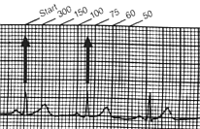

To understand this graph in another way, there are 3 R waves within a span of 10 large boxes. 10 large boxes equals about two seconds of real time. Since 60 seconds=one minute, the number of R waves within a two second time frame is multiplied by 30. The heart rate in the above picute can be estimated at somewhere around 90 beats/min. Since the R waves are spaced equally apart, your calculation is probably accurate. Knowing nothing else about EKGs, the above rhythm most likely originates in the SA node because it is within the sinoatrial pacemaker’s intrinsic rate. Rate determination is simple. Besides looking at the number on the monitor, use the following methods:

1) # R waves / 6 second strip x 10= beats per minute

2) Start when an R wave falls on a border of a large square. Note where the next R wave occurs. If you remember the following sequence, you can reliably estimate beats per minute. Again, start when the R wave falls on a bold horizontal line. Then count out 300, 150, 100, 75, 60 and 50. The R wave in the above illustration falls between the horizontal bold lines that correspond to 100 and 75. Thus, the heart rate is about 90/min.

VI. Where does the rhythm originate, and does it cross a threshold?
It is extremely important to determine the site of dysrhythmia origin. Rate provides one clue to site of propagation, but the characteristics of the P wave and QRS complexes are more diagnostic. Before going into specific dysrhytmias, note the following thresholds of classification:
LESS THAN 60 bpm: BRADYcardia
MORE THAN 100 bpm: TACHYcardia

SUPRAVENTRICULAR DYSRHYTHMIAS
These nasty bastards originate somewhere ABOVE the ventricles. The SA node, AV node, or other ectopic pacemakers can initiate a supraventricular dyrhythmia. Characteristics of a supraventricular rhythm include the presence of a P wave and a narrow QRS. We will examine the supraventricular rhythms detail.

A) SINUS RHYTHM
Rate: 60-100 bpm
Rhythm: Regular
P waves: Uniform
PR Interval: 0.12-0.20 s
QRS: 0.12 seconds or less
P to QRS: 1:1 ratio

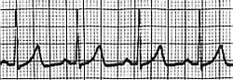

B) SINUS TACHYCARDIA

Rate: 100 bpm +
Rhythm: Regular
P waves: Uniform
PR interval: 0.12 to 0.20 s
P to QRS: 1:1

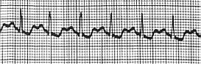

C) SINUS BRADYCARDIA
Rate: less than 60 bpm
Rhythm: Regular
P waves: Uniform
PR interval: 0.12 to 0.20 seconds

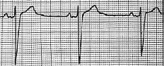

D) SINUS DYSRHYTHMIA

Rate: 60-100 bpm
Rhythm: Irregular R to R interval
P waves: Uniform
PR interval: 0.12 to 0.20 seconds

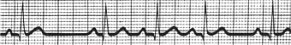

E) PREMATURE ATRIAL COMPLEX (PAC)

This beat originates from somewhere in the atria. It occurs out of step with the sinus rhythm. The difference between an ectopic atrial beat and a sinus beat lies in the comparison of the P wave. The P wave of the PAC differs from the P wave generated from the SA node. The QRS complex is usually identical to that found in within the sinus rhythm. Indeed, ventricles are depolarized by a PAC as well as a sinus beat. Furthermore, conduction through the ventricular system is usually the same. There is usually a NONCOMPENSATORY pause following a PAC. Because the ventricles were depolarized by the ectopic focus, they take “longer” to reset. Consequently, the following sinus beat occurs before it was expected. Examine the following EKG strip. You will note the appearance of sinus rhythm until the ventricles are depolarized by a P wave with different morphology. Because QRS complexes are identical, we can assume that the abnormal P wave was generated by an atrial ectopic focus. PAC’s are of variable clinical significance. They can be due to caffeine uptake, heightened sympathetic tone, or ischemia. When PACs occur in rapid succession (3 or more consequtive PAC’s), the PAC’s are classified as a “run” of atrial tachycardia. The tachycardia is considered paroxysmal if it occurs suddenly, without warning. The term “complex” is utilized instead of contraction because the EKG only indicates ELECTRICAL activity, not necessarily mechanical contraction.

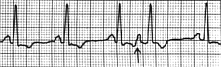
- Different P wave
- Often noncompensatory pause
- Conduction through ventricles (QRS complex) often the same
- PR interval often normal

F) ATRIAL TACHYCARDIA (PAROXYSMAL TACHYCARDIA/PAT/PSVT)

Rate: 150/min+
Rhythm: Regular
P waves: Usually present but may be buried in QRS complex if rate is too fast. Different P waves from SR
PR Interval: 0.12-0.20 seconds
QRS duration: Usually < 0.12s

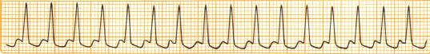

G) ATRIAL FLUTTER:
Rate: Variable
Rhythm: Regular
P waves: Saw tooth baseline appearance to EKG
PR interval: not measurable
P:QRS ratio: Variable, sometimes presents with a 2:1, 3:1, or 4:1 block

In the tracing below, notice the saw tooth baseline appearance. The P waves appear in rapid succession, and it is difficult to tell how many P waves are required to stimulate the QRS. The second QRS complex is preceeded by three flutter waves, and the third flutter complex looks like two flutter waves preceed it. The rhythm is called atrial flutter with variable “block” . “Block” illustrates that not all P waves are conducted through to the ventricles.
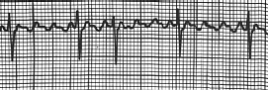

H) ATRIAL FIBRILLATION
Rate: Variable
Rhythm: Irregularly irregular
P waves: Not discernable/fibrillatory baseline
PR interval: Not measurable

A-fib is one of the most common dysrhythmias encountered in the clinical setting. Afib onset correlates with increasing age. The hallmark feature of a-fib is the irregular R to R intervals. A fibrillatory baseline is also seen in patients with a-fib. Atrial depolarization is chaotic and rapid. Atrial firing often exceeds 300 per minute but only some of the “P” waves produce a QRS. Because of the variable atrial conduction, the ventricles can be slowly, rapidly, or irregularly depolarized. Effective atrial activity is lost, and the patient immediately loses about 30% of effective cardiac output. Atrial fibrillation does not permit adequate atrial filling, and atrial “kick” is thus diminished. A fib is readily diagnosed from the appearance of the irregularly spaced R waves. Examine the tracings below:

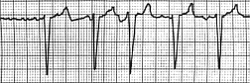

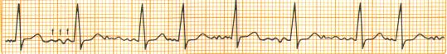

Note the “F” or fibrillation waves producing variable conduction to the ventricles. The QRS is identical from complex to complex, but the R to R intervals are not evenly spaced. This dysrhythmia predisposes patients to an increased risk of stroke partially because microembolisms can originate on the incompetent valve leaflets.

I) PREMATURE JUNCTIONAL COMPLEX
The PJC is a complex originating from the atrioventricular node. When conduction pathyways through the SA node are altered or damaged, the A/V node can assume the function of the heart’s primary pacemaker. When a beat originating in the A/V junction occurs unexpectedly, it is classified as a PJC. The salient features of a PJC include P waves that are:
- Inverted
- Retrograte
- Retrograte and inverted
- Antegrate and abbreviated
- Absent
The QRS complex is often of normal morphology and duration. If the PR interval is less than 0.12 seconds, then it is unlikely that the particular complex could have stimulated the ventricles. Recall that SA nodal fibers are of the slow response type and require a certain amount of “down time” prior to depolarization. Thus, abbreviated PR intervals indicate junctional complexes. If the SA node is somehow damaged as is the case with inferior wall MI’s, P waves will not be seen on the EKG. Sometimes complexes produced by the A/V node are conducted in a retrograde fashion to atrial tissue. Retrograde conduction will produce negative deflections on the EKG that appear as INVERTED P waves. If it takes time for the atria to depolarize, the P wave is often seen after the QRS complex! Obviously, P waves that are retrograde and inverted almost always indicate ineffective atrial contraction. Examine the EKG below for features of a PJC:
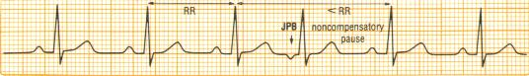
The P wave in the above tracing is inverted, representing RETROGRADE atrial conduction. Premature junctional complexes can occur in rapid succession and cause a JUNCTIONAL TACHYCARDIA. How do you know the tachycardia is junctional vs atrial vs supraventricular? The answer is often: YOU DON’T. That’s why the term “supraventricular tachycardia” exists. Because rates are too rapid to allow the examiner’s eye to distinguish P wave morphology, it is often problematic to distinguish truly junctional tachycardias vs. atrial ones. Features suggestive of a true junctional tachycardia include:

- Rate around 100 to 150/min
- Absence of P waves
- Retrograte, inverted, or retrograde and inverted P waves
- Usually narrow QRS complex

The strip below depicts a “true” junctional tachydysrhythmia (Sometimes called accelerated junctional rhythm just to make things more confusing). Look! Inverted P waves before every narrow QRS! How convenient! If the strip below represents a 5 second strip (25 estimated large squares), then the rate is estimated at: 150/min.
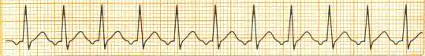
What would be the most likely rhythm diagnosis of an EKG with the following features:
Rate: 40/ min
P waves: Absent
QRS: Narrow, < 0.12 s
PR interval: not measurable
R to R interval: Regular

ANSWER: Junctional rhythm. The rate corresponds with the A/V node’s intrinsic pacing rate. Furthermore, P waves are absent and QRS complexes are narrow. Regular R to R intervals eliminate the possibility of a slow a-fib. The rhythm CANNOT be sinus bradycardia because the QRS complexes are not preceeded by P waves.

VENTRICULAR DYSRHYTHMIAS

The following EKGs represent some of the most life threatening dysrhythmias. Of course, the clinician must always treat the patient prior to the monitor. However, the following tracings can represent dire emergencies. Features suggestive of a ventricular rhythm include:
- Wide and bizarre QRS
- Rate of 20-40/min
- “Mountain range” appearance of the EKG
Ventricular rhythms are often easy to discern. Starting with the most benign and proceeding to the more pathological, we will first examine a solitary premature ventricular contraction. The dreaded “PVC” represents premature ventricular depolarization. The QRS is often wide and bizarre. Repolarization of cardiac tissue is often altered, and the deflection of the T wave is sometimes opposite that of the QRS complex. QRS duration is greater than 0.12 seconds.

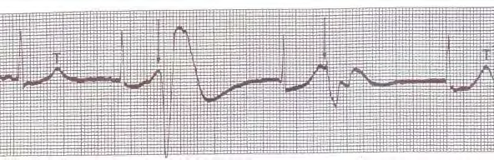

Note the wide QRS and oppositely deflected T wave. No P wave is seen prior to the PVC. Problems occur when PVCs occur with rapid succession. PVCs can be multi-focal in origin. Simply put, the PVCs share similar characteristics of lengthened QRS contraction and opposite T wave deflection. However, the PVC’s are different in appearance. Multiform PVCs almost always indicate ventricular irritability:

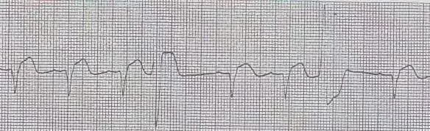

The fourth beat is a PVC with a mostly negative QRS deflection. The seventh QRS complex is a mostly positively deflected QRS complex. This EKG tracing thus showcases multiform PVCs.

VENTRICULAR TACHYCARDIA (VT)

Ventricular tachycardia occurs when more than three PVCs occur consequtively. This rhythm is extremely dangerous and can deteriorate into the dreaded V-fib and eventual Asystole. People presenting with ventricular tachycardia may still maintain a pulse. V-tach always necessitates physician intervention. The following strips represent runs of VT:

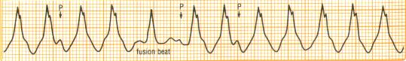
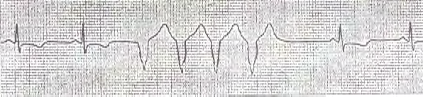
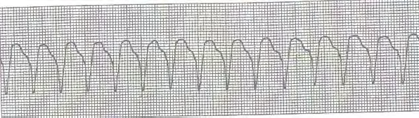
VENTRICULAR FIBRILLATION (VF)
V-fib represents totally chaotic and ineffective ventricular depolarizations. The QRS complexes are not only wide and bizarre, but of dissimilar morphology. The EKG has the appearance of a “squiggly line.” Cardiac output falls to zero as does pulse and blood pressure. V-fib necessitates immediate intervention with countershock, or defibrillation. Defibrillation acts as a massive tripped circuit-breaker. Defibrillation, when appropriately applied, allows the heart to “reset” itself and resume normal conduction activity. Often, the myocardium is so irritable that drugs are required to further suppress ectopic activity. Always confirm pulselessness prior to defibrillation. V fib is truly a dire emergency.

Fine v-fib:
QRS complexes are wide, shallow in amplitude. Note the presence of a wavy baseline.
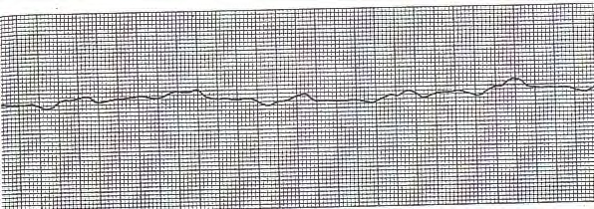

Coarse v-fib:
This EKG is more representative of “classical” ventricular fibrillation:
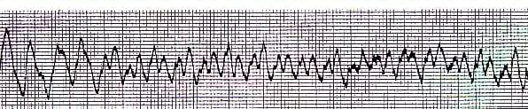
BLOCKS AND PACEMAKER COMMENTS TO FOLLOW. BLOCKS WILL BE REVIEWD PRIOR TO ACLS/CARDIO.

